I Think I Need a Houseboat
Time Limit: 1000MS |  | Memory Limit: 10000K
Total Submissions: 61332 |  | Accepted: 25586
Description
Fred Mapper is considering purchasing some land in Louisiana to build his house on.
采购
In the process of investigating the land, he learned that the state of Louisiana is
在...的过程中 调查 国家
actually shrinking by 50 square miles each year, due to erosion caused by the
事实上 正在以50平方米每年的速度萎缩 由于...的 侵蚀
Mississippi River. Since Fred is hoping to live in this house the rest of his life, he
余生
needs to know if his land is going to be lost to erosion.
After doing more research, Fred has learned that the land that is being lost forms a
研究 正在失去一个半圆的形状
semicircle. This semicircle is part of a circle centered at (0,0), with the line that bisects the circle being the X axis. Locations below the X axis are in the water. The
平分
semicircle has an area of 0 at the beginning of year 1. (Semicircle illustrated in the Figure.)
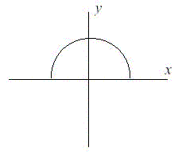
Input
The first line of input will be a positive integer indicating how many data sets will be included (N). Each of the next N lines will contain the X and Y Cartesian coordinates of the land Fred is considering. These will be floating point numbers measured in miles. The Y coordinate will be non-negative. (0,0) will not be given.
Output
For each data set, a single line of output should appear. This line should take the form of: “Property N: This property will begin eroding in year Z.” Where N is the data set (counting from 1), and Z is the first year (start from 1) this property will be within the semicircle AT THE END OF YEAR Z. Z must be an integer. After the last data set, this should print out “END OF OUTPUT.”
Sample Input
2
1.0 1.0
25.0 0.0
Sample Output
Property 1: This property will begin eroding in year 1.
Property 2: This property will begin eroding in year 20.
END OF OUTPUT.
Hint
1.No property will appear exactly on the semicircle boundary: it will either be inside or outside.
2.This problem will be judged automatically. Your answer must match exactly, including the capitalization, punctuation, and white-space. This includes the periods at the ends of the lines.
3.All locations are given in miles.
Source
Mid-Atlantic 2001

问题描述：
Fred Mapper 正在考虑在路易斯安那州购买一些土地来建他自己的房子。在研究土地的过程中，他发现，路易斯安那州的土地每年都会被密西西比河侵蚀掉 50 平方里。因为 Fred 希望在这个房子里度过余生，所以他需要知道他的那些土地是否会被侵蚀掉。
在做了更多的调查之后，Fred 发现这些土地是以半圆的形状被侵蚀的。这个半圆所对应的正圆的圆心在坐标原点 (0, 0), 坐标轴 x 轴将这个圆切成两半。在 x 轴下方的区域是河流。在第一年刚开始的时候，这个半圆的面积是 0.（半圆如图所示。）
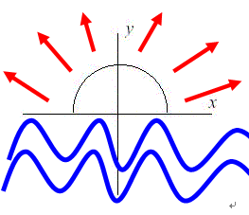
红色为侵蚀方向，蓝色为河水

问输入Fred Mapper家的坐标（X,Y），他家所在的位置什么时候被河水侵蚀。

解题思路：
Fred Mapper的家（X,Y）到侵蚀中心（0，0）的距离就是侵蚀半径R
那么Area = 1/2*pi*R 就是侵蚀到Fred Mapper家时的侵蚀面积
而侵蚀速度为每年50
那么侵蚀到Fred Mapper家需要 RestYear = Area/50 = pi*R/100 年
又要求从第一年开始计算，最后一年不够一年按一年计算，那么RestYear+1取整就可以了。

